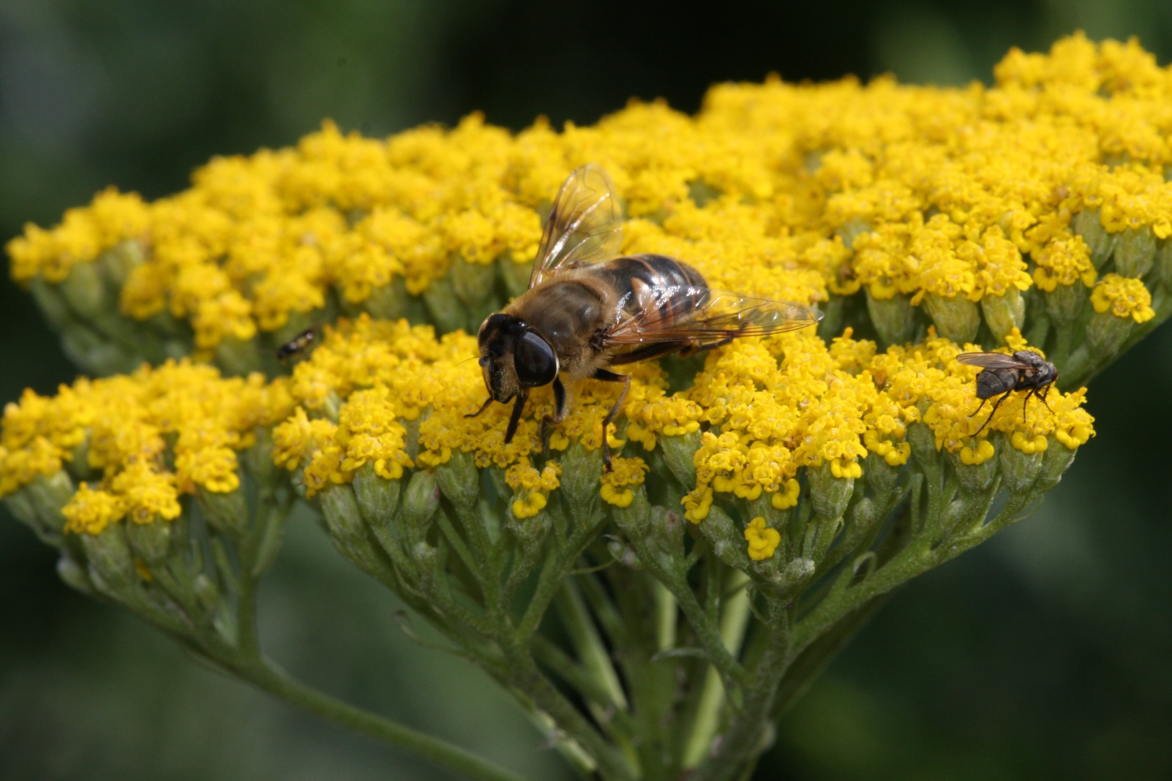

© Sebastian Schuhbeck, www.schuhbeck.info/sprechblasen.htm

